CS 210 Project Three
APA

Cynthia Turner
Southern New Hampshire University
CS 210: Programming Languages 2026 C-1
Professor Barbara Hecker
Feb. 22nd, 2026

Program Design and Functionality
The Grocery Tracking Program was developed in C++ using object-oriented programming principles to analyze grocery purchase data from a text file. The program reads item names from an input file and calculates the frequency of each item purchased during the day. The primary objective of the application is to assist the Corner Grocer in identifying purchasing trends so that store layout decisions can be optimized.
To organize the program effectively, a class named GroceryTracker was implemented. This class contains private data members, including a map<string, int> container used to store grocery item names and their corresponding purchase frequencies. The use of a map provides efficient data storage and retrieval while automatically sorting items alphabetically.
The constructor initializes the input file name and the backup file name. The LoadDataFromFile() function reads each word from the file CS210_Project_Three_Input_File.txt and updates the map by incrementing the frequency count for each item encountered. This allows the program to dynamically process large amounts of data efficiently.
The program automatically generates a backup file named frequency.dat using the CreateBackupFile() function. This file contains each grocery item paired with its purchase frequency and serves as a permanent record of processed data. The backup file is created without user intervention at the beginning of program execution.
A user-friendly, menu-driven interface allows interaction with the system. The available options include:

- Searching for the frequency of a specific grocery item.
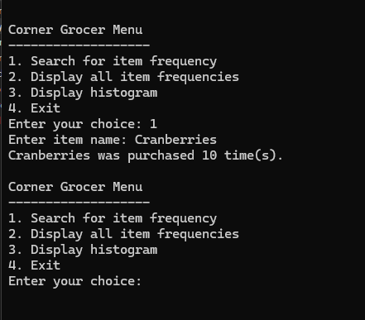
- Displaying all grocery items and their frequencies.
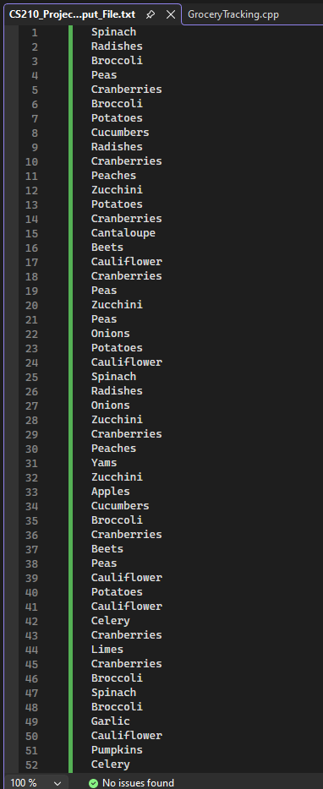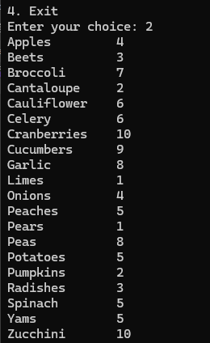
- Displaying a histogram representation of item frequencies.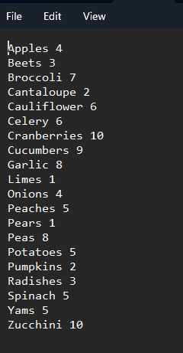
- Exiting the program.
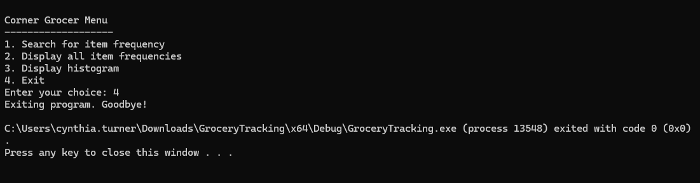

Input validation is implemented to ensure that users select valid menu options. If an invalid option is entered, the program clears the error state and prompts the user to enter a valid selection. This prevents runtime errors and enhances program reliability.
The histogram feature provides a text-based graphical representation of purchase frequencies. Each grocery item is displayed followed by a number of asterisks equal to its purchase count. This allows users to quickly visualize which products are purchased most frequently.
Industry standard best practices were followed throughout development. These include meaningful variable and function names, consistent indentation, clear in-line comments, separation of functionality into reusable functions, and encapsulation of data within a class structure. These practices improve the code and readability, maintainability, and efficiency.
Overall, the program successfully fulfills all functional requirements outlined in the project guidelines while demonstrating structured design, file processing, and secure data handling.

